**MIE1622 Assignment 3 Report**

Kaiyan Jiang 1003848189

March 27, 2022

**Introduction:**

This assignment is to model a credit-risky portfolio of corporate bonds. The following three scenarios are generated:

Monte Carlo approximation 1: 5000 in-sample scenarios (1000 $∙$ 5 systemic scenarios and 5 idiosyncratic scenarios for each systemic), non-Normal distribution of losses.

Monte Carlo approximation 2: 5000 in-sample scenarios (5000 systemic scenarios and 1 idiosyncratic scenario for each systemic), non-Normal distribution of losses.

True distribution: 100000 out-of-sample scenarios (100000 systemic scenarios and 1 idiosyncratic scenario for each systemic), non-Normal distribution of losses.

Another three in-sample Normal model are also generated for three scenarios.

Two portfolios are used in generation: (1) one unit invested in each of 100 bonds; (2) equal value (dollar amount) is invested in each of 100 bonds. For each portfolio the VaR and CVaR at quantiles 99% and 99.9% are computed.

**Analyze results:**

Output:

Portfolio 1:

Out-of-sample: VaR 99.0% = $38321618.70, CVaR 99.0% = $46794116.16

In-sample MC1: VaR 99.0% = $37990416.99, CVaR 99.0% = $45799869.46

In-sample MC2: VaR 99.0% = $38038405.12, CVaR 99.0% = $45872926.11

In-sample No: VaR 99.0% = $26787684.82, CVaR 99.0% = $29756368.54

In-sample N1: VaR 99.0% = $26491463.60, CVaR 99.0% = $29428424.08

In-sample N2: VaR 99.0% = $26519910.13, CVaR 99.0% = $29458432.44

Out-of-sample: VaR 99.9% = $57746597.86, CVaR 99.9% = $66018407.52

In-sample MC1: VaR 99.9% = $55523849.35, CVaR 99.9% = $62647748.19

In-sample MC2: VaR 99.9% = $55114537.33, CVaR 99.9% = $63241821.44

In-sample No: VaR 99.9% = $33479796.05, CVaR 99.9% = $35905245.40

In-sample N1: VaR 99.9% = $33112063.18, CVaR 99.9% = $35511594.27

In-sample N2: VaR 99.9% = $33144030.43, CVaR 99.9% = $35544837.55

Portfolio 2:

Out-of-sample: VaR 99.0% = $27713705.31, CVaR 99.0% = $33881935.48

In-sample MC1: VaR 99.0% = $27719460.26, CVaR 99.0% = $33612996.26

In-sample MC2: VaR 99.0% = $27628271.30, CVaR 99.0% = $33495742.05

In-sample No: VaR 99.0% = $21418809.63, CVaR 99.0% = $23624245.52

In-sample N1: VaR 99.0% = $21302724.94, CVaR 99.0% = $23499808.83

In-sample N2: VaR 99.0% = $21254838.60, CVaR 99.0% = $23444263.10

Out-of-sample: VaR 99.9% = $42040671.32, CVaR 99.9% = $48754397.09

In-sample MC1: VaR 99.9% = $41223583.11, CVaR 99.9% = $46371258.71

In-sample MC2: VaR 99.9% = $40785629.53, CVaR 99.9% = $46847040.67

In-sample No: VaR 99.9% = $26390380.74, CVaR 99.9% = $28192247.67

In-sample N1: VaR 99.9% = $26255468.71, CVaR 99.9% = $28050511.97

In-sample N2: VaR 99.9% = $26190316.29, CVaR 99.9% = $27979101.73

Loss distributions of out-of-sample and in-sample results:

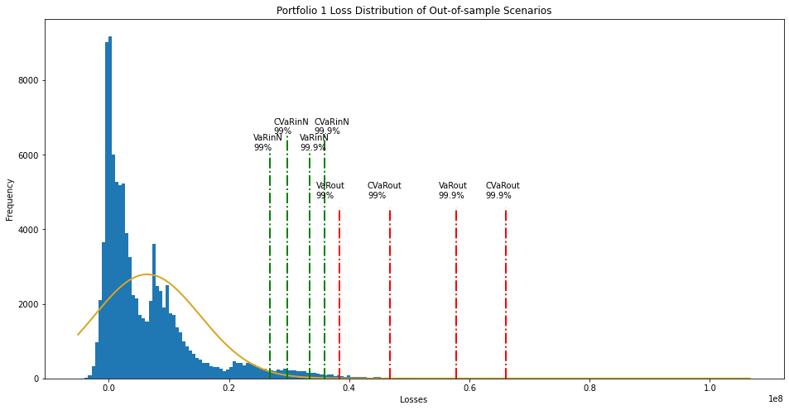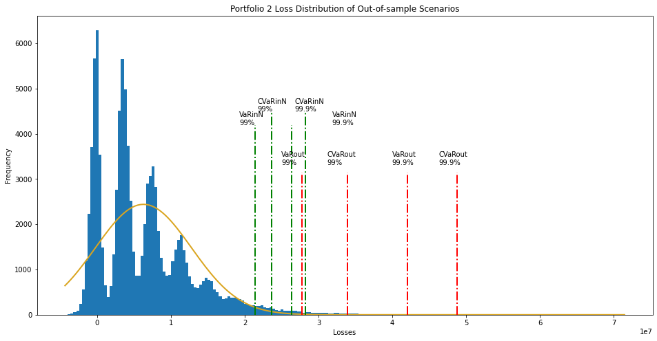

Figure 1: Loss Distribution of Out-of-Sample Scenarios for both Portfolios

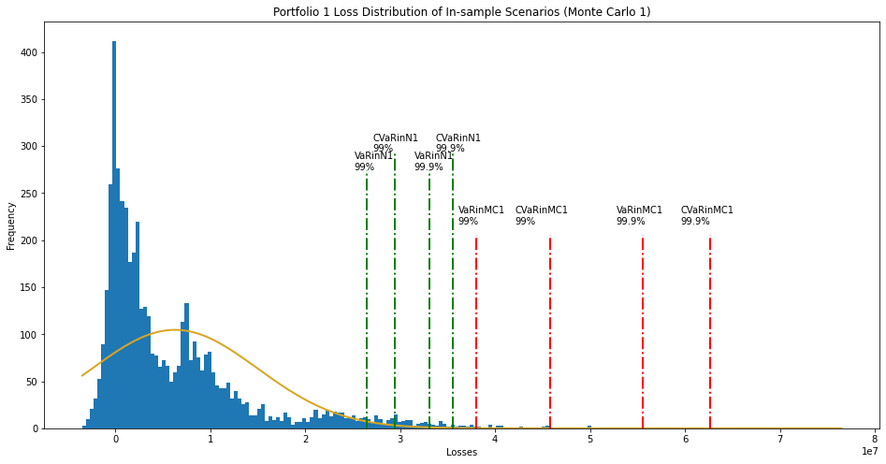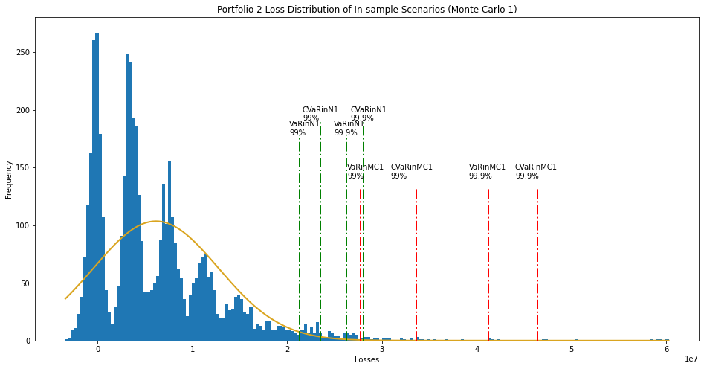

Figure 2: Loss Distribution of In-Sample Scenarios for both Portfolios (Monte Carlo 1)

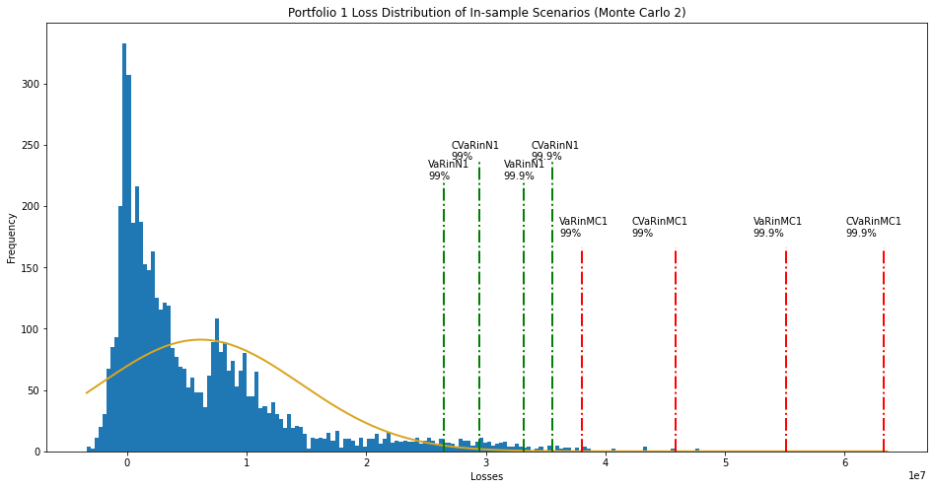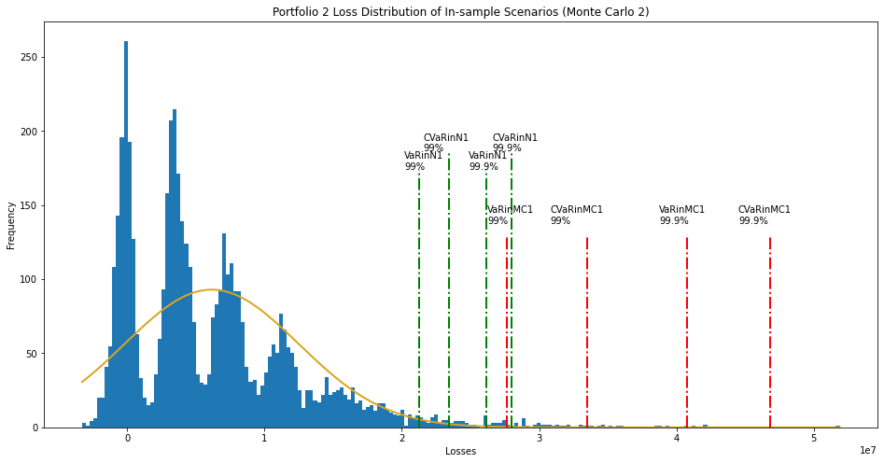

Figure 3: Loss Distribution of In-Sample Scenarios for both Portfolios (Monte Carlo 2)

|  |  |  |  |  |  |  |  |  |
| --- | --- | --- | --- | --- | --- | --- | --- | --- |
|  | 99% VaR | Sampling Error | 99.9% VaR | Sampling Error | 99% CVaR | Sampling Error | 99.9% CVaR | Sampling Error |
| True Distribution | 38321618.70 | - | 57746597.86 | - | 46794116.16 | - | 66018407.52 | - |
| Monte Carlo 1 | 37990416.99 | 0.86% | 55523849.35 | 3.59% | 45799869.46 | 2.59% | 62647748.19 | 5.84% |
| Monte Carlo 2 | 38038405.12 | 0.74% | 55114537.33 | 4.56% | 45872926.11 | 2.40% | 63241821.44 | 4.81% |

Sampling Error Analysis:

Sampling Error is the difference between Monte Carlo approximation and the true distribution (out-of-sample scenarios). In the following two tables, show the sampling error for both portfolios.

*Table 1: Portfolio 1 - VaR and CVaR Sampling Error Between In-Sample and Out-of-Sample Scenarios*

|  |  |  |  |  |  |  |  |  |
| --- | --- | --- | --- | --- | --- | --- | --- | --- |
|  | 99% VaR | Sampling Error | 99.9% VaR | Sampling Error | 99% CVaR | Sampling Error | 99.9% CVaR | Sampling Error |
| True Distribution | 27713705.31 | - | 42040671.32 | - | 33881935.48 | - | 48754397.09 | - |
| Monte Carlo 1 | 27719460.26 | 0.02% | 41223583.11 | 1.94% | 33612996.26 | 0.97% | 46371258.71 | 5.67% |
| Monte Carlo 2 | 27628271.30 | 0.31% | 40785629.53 | 2.99% | 33495742.05 | 1.39% | 46847040.67 | 4.54% |

*Table 2: Portfolio 2 - VaR and CVaR Sampling Error Between In-Sample and Out-of-Sample Scenarios*

Both Monte Carlo approximations performed well for both portfolios. From the above tables, the sampling error are very small. And for both approximations, we can observe that the Monte Carlo approximation 2 performed better than Monte Carlo approximation 1. Since compared to the sampling errors of Monte Carlo approximation 2 for VaR and CVaR for both quantiles 99% and 99.9% are all less than the sampling errors of Monte Carlo approximation 1.

Model Error Analysis:

Model Error is the error that occurred if we wrongly assumed the counterparty losses follow Normal distribution. The following tables identified the model error between the three in-sample Normal approximations and the out-of-sample (true) distribution.

|  |  |  |  |  |  |  |  |  |
| --- | --- | --- | --- | --- | --- | --- | --- | --- |
|  | 99% VaR | Model Error | 99.9% VaR | Model Error | 99% CVaR | Model Error | 99.9% CVaR | Model Error |
| True Distribution | 38321618.70 | - | 57746597.86 | - | 46794116.16 | - | 66018407.52 | - |
| Normal Distribution | 26787684.82 | 30.10% | 33479796.05 | 42.02% | 29756368.54 | 44.46% | 35905245.40 | 52.15% |
| Monte Carlo N1 | 26491463.60 | 30.87% | 33112063.18 | 42.66% | 29428424.08 | 45.32% | 35511594.27 | 52.83% |
| Monte Carlo N2 | 26519910.13 | 30.80% | 33144030.43 | 42.60% | 29458432.44 | 45.24% | 35544837.55 | 52.77% |

*Table 3: Portfolio 1 - VaR and CVaR Model Error Between In-Sample and Out-of-Sample Scenarios*

|  |  |  |  |  |  |  |  |  |
| --- | --- | --- | --- | --- | --- | --- | --- | --- |
|  | 99% VaR | Model Error | 99.9% VaR | Model Error | 99% CVaR | Model Error | 99.9% CVaR | Model Error |
| True Distribution | 27713705.31 | - | 42040671.32 | - | 33881935.48 | - | 48754397.09 | - |
| Normal Distribution | 21418809.63 | 22.71% | 26390380.74 | 37.23% | 23624245.52 | 37.01% | 28192247.67 | 48.91% |
| Monte Carlo N1 | 21302724.94 | 23.13% | 26255468.71 | 37.55% | 23499808.83 | 37.46% | 28050511.97 | 49.25% |
| Monte Carlo N2 | 21254838.60 | 23.31% | 26190316.29 | 37.70% | 23444263.10 | 37.66% | 27979101.73 | 49.42% |

*Table 4: Portfolio 2 - VaR and CVaR Model Error Between In-Sample and Out-of-Sample Scenarios*

Compared to sampling error, the model error for models that assumed to be normally distributed is much larger, lies in a significant range from 22.71% to 52.77%. Compare within the two portfolios, portfolio 2 performed better than portfolio 1 for all approximations.

**Discussion:**

If you report the in-sample VaR and CVaR to decision-makers in your bank, what consequences for the bank capital requirements it may have?

If the bank still invests on the two portfolios, reporting non-normal Monte Carlo approximations to decision-makers, they may be able to get a more accurate prediction than reporting normal Monte Carlo approximations. Since compared to non-normal Monte Carlo approximations, normal Monte Carlo approximations underestimates more risk which may cause the bank to have a higher underestimation in bank capital requirements.

However, if the non-normal Monte Carlo approximations are reported, the decision is still dangerous, and the bank will have an underestimation in bank capital requirements. This is because the in-sample VaR and CVaR are generally below the true values with a few exceptions. The required bank capital is based on VaR. The larger the VaR, the more capital required. If the VaR is underestimated here, the bank cannot prepare sufficient capital to cover the loss.

Can you suggest techniques for minimizing impacts of sampling and model errors?

The impacts of sampling error can be reduced by increasing the sample size and increasing the number of scenarios as the number of scenarios and sampling error are inversely related.

The impacts of model error can be minimized by not assuming any existed pattern such as Normal distribution or using a distribution model that is closer to the true distribution. In the previous analysis, the normal distribution has a very high model error. And our true distribution is quite right-skewed with a high tail risk, while the normal distribution cannot cover the tail risks. Thus, a non-normal distribution can be used instead, or not assuming any distribution since the true data does not have any pattern.

Lastly, if the decision-makers want to make a more accurate prediction, they can use more historical data rather than Monte Carlo simulations. Since the Monte Carlo is random, using historical data may reduce the randomness. Still, the current circumstance should also be considered by the decision-makers, as the financial status is changing every day.